Product Name: CABINET, FLAMMABLE, STANDING HEIGHT, 2 DOOR, SLAM LATCH, AUTO-CLOSE, 36"L x 35.1"H x 22"D, SS LC189-36SLASY
SPECIFICATIONS
Materials
- 304 stainless steel construction with a polished No. 4 finish
DESCRIPTION:
- Flammable Solvent Storage Cabinets are specifically designed for the storage of flammable and combustible liquids.
- Construction meets the requirements listed by UFC, OSHA and NFPA No. 30-1993 and are UL -listed.
- A 2” deep liquid-tight pan covers the entire bottom of the cabinet to contain liquid leaks and spills. Two diametrically opposed vents with spark screens are provided in the back of the cabinet as well as a grounding screw.
- Cabinets are labeled: FLAMMABLE - KEEP FIRE AWAY
- Includes doors that are self-closing and synchronized so that both doors will always fully close. The right-hand door is equipped with a three-point latching system that automatically engages when the doors close.
- Each door can also be equipped with a fusible link hold-open feature that ensures the door closes should the temperature outside cabinet exceed 165°F.
INCLUDES: 1 standing height Acid Storage base cabinet
Dimensions 35.1” T X 22.0” D, Length 36.0”
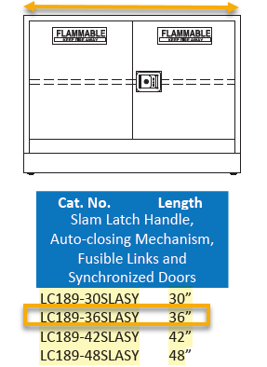
- Weight: Estimated weight, 190 lbs.

